HTML and CSS Design deliverables

Student Name: **Harshavardhan Phoujdar**

Student number: **D16123828**

Content

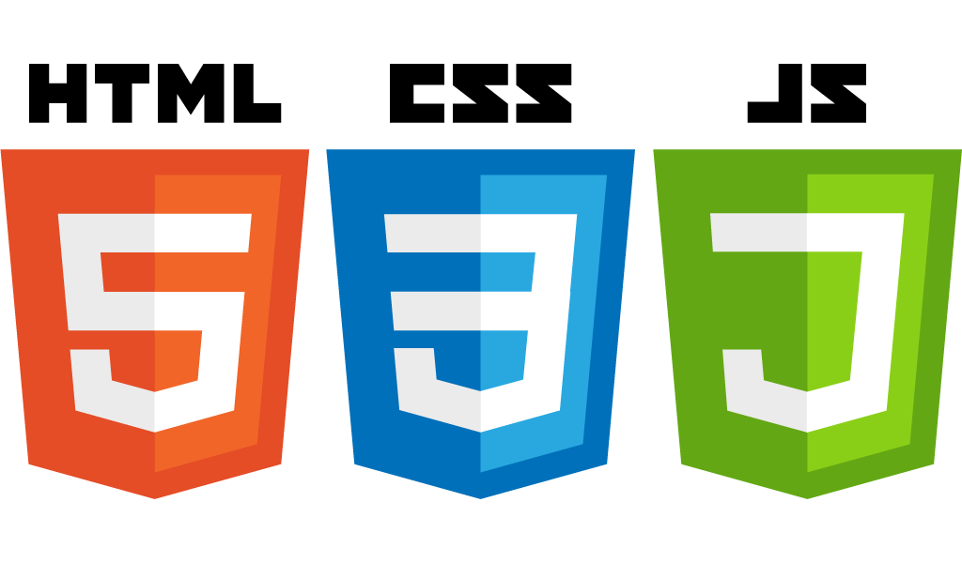

50% 40% 10%

Major part of the coding/markup was done in HTML and CSS, it took me a lot of time to understand CSS and the main two properties which came handy were the position and display.

Initially I used a external CSS file and linked it to html and did design in CSS and skeleton in HTML, but soon I found out that it made more sense to define key rules (Such as display ) in externally linked CSS, and more customizable properties (such as positioning) inline. Although this increased code redundancy, but was much easier to do and implement personally.

The 4 pages I choose to do were

1 Home

2 Products

3 About

4 Contact

As I was a little confused regarding the merging of both assignments given by Keith and Evin, I included a section titled ‘Keith’s Part’.

The ‘Identity and website design’ project was done in Dreamweaver.

The ‘Authoring Principles’ project was done in Net beans.

And both were linked using <a href>

Analysing Elements

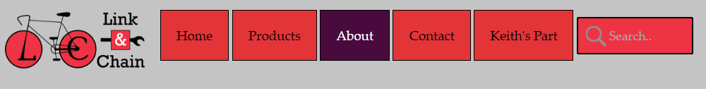

The logos used were PNG which offer a much smaller size to its JPEG compatriot.

The header comprised of unordered lists styled in CSS, with changed background and text colour values a:Hover , along a little animation in the search bar with an attempt to introduce a much richer UI.

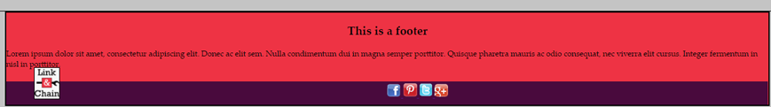

The footer was kept nice and simple sticking with the dual colour theme.

Colour Palette:

Along with a major influence of

White #fff and Black #000,

a pinkish # ee3344, and purple # 490a3d colour theme was used throughout.

Sitemap

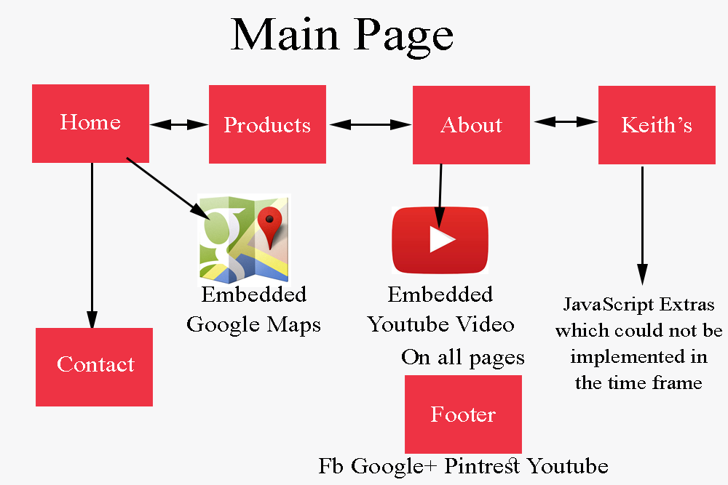

Grid layouts remain constant across all pages with similar metrics

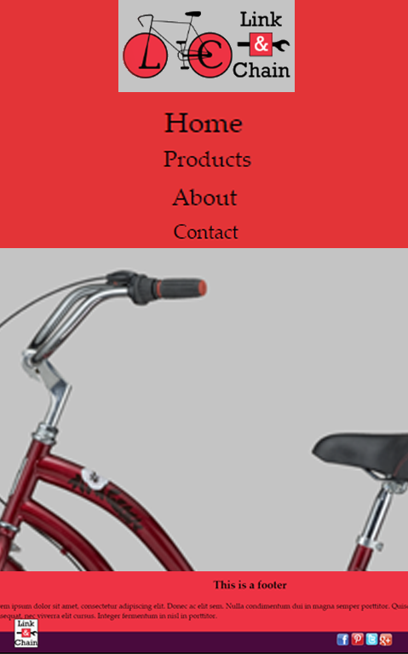

Mobile metrics

479x 767

Desktop Metrics